**Creating a Web Service in Java using NetBeans IDE**

This document provides step-by-step instructions to create and deploy a web service in Java using NetBeans IDE and GlassFish 4.0. In the project, we will create a calculation service.

**Prerequisites:**

* NetBeans 8.0 IDE (Can be downloaded from here - [Link](https://netbeans.org/downloads/))

**Step 1: Create a Java Web Project**

Open NetBeans IDE

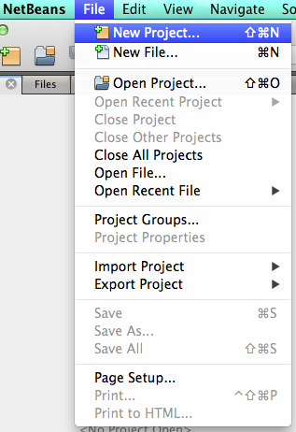Click on New Project and choose Java Web 🡪 Web Application

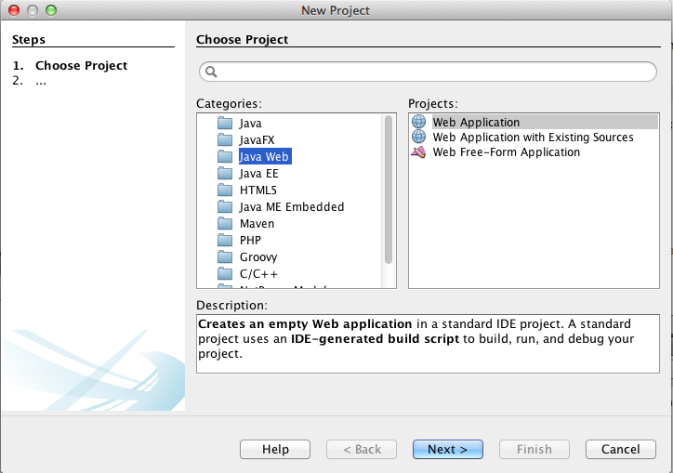

🡪

Enter the Project Name: CalculationWS, using the default settings and then click on “Finish”.

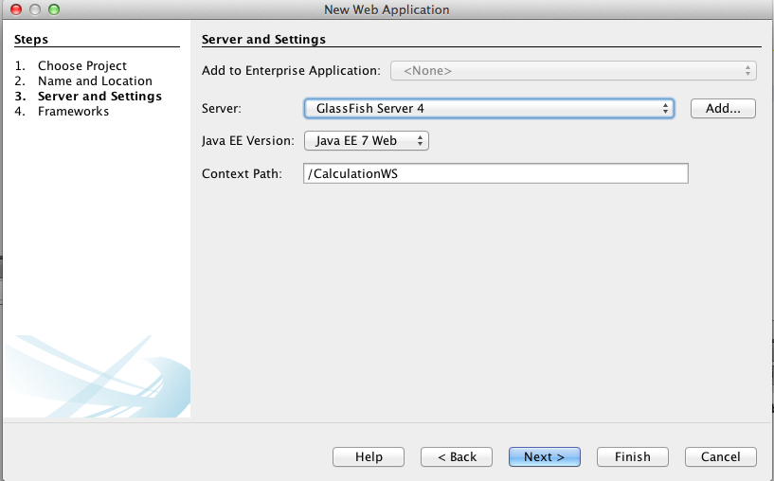

Now the Project has been created.

**Step 2: Create a Web Service**

Now go to the Project Tree Structure on the left side of the window.

Right click on the project and select “New” and then choose “Web Service”

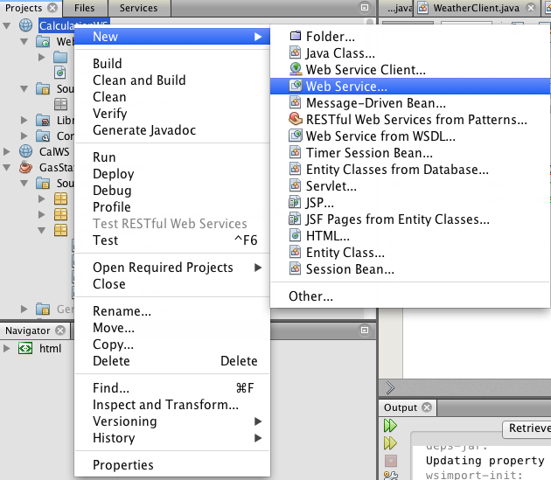

Specify web service name “CalWS” and package name “CalculationWS”. Click on “Finish”.

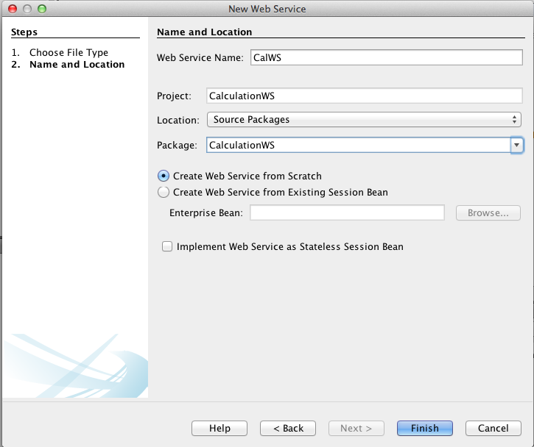

Open CalWS.java file, replace the original hello() function with the following code:

@WebMethod(operationName = "Addition")

public String Addition(@WebParam(name = "value1") String value1,@WebParam(name = "value2") String value2 ) {

float value=Float.valueOf(value1)+Float.valueOf(value2);

return (Float.toString(value));

}

Now the web service is created.

**Step 3: Deploy and Test Web Service**

Right click on the project and select “Deploy”

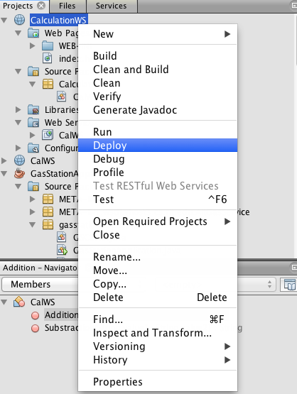

This is to deploy all the web services in this project. If success, you will see:

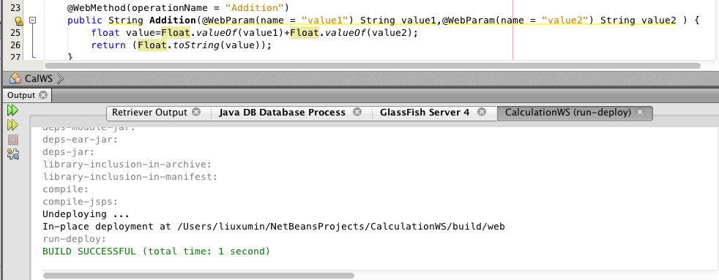

To test the web service, right click on the service and select “Test Web Service”

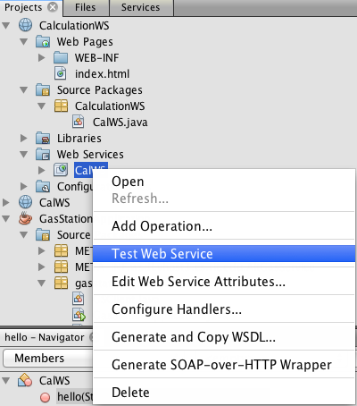

You will see:

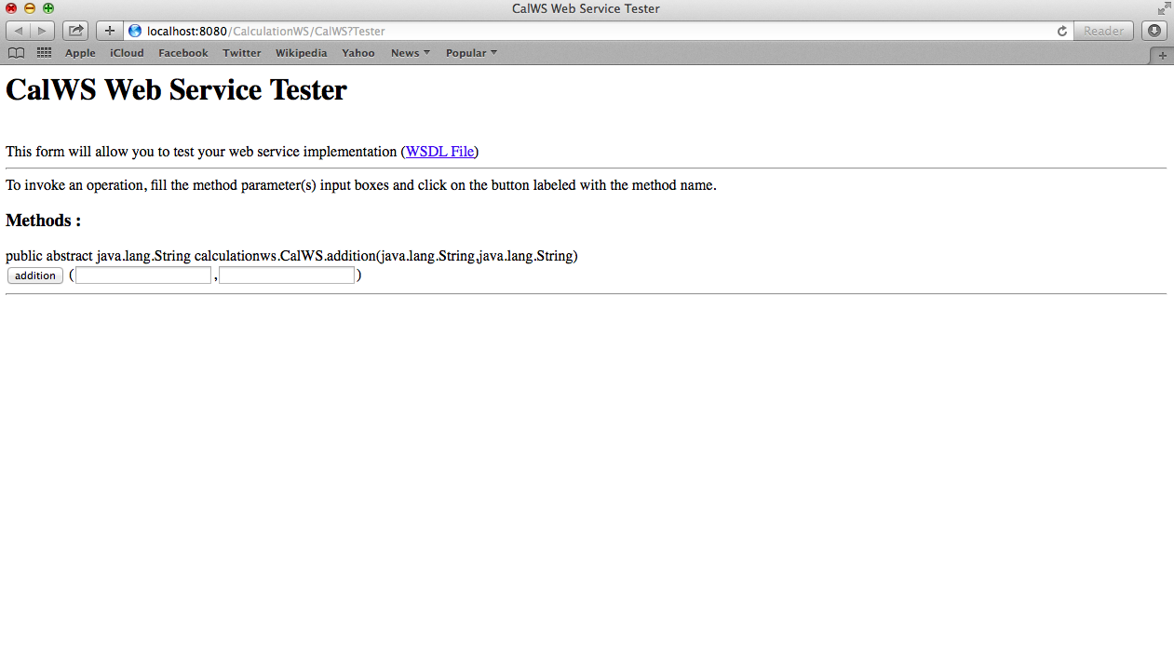

Right Click on the project and select “Clean and Build”, a war file will be automatically generated under “dist” sub-directory.